Establishing and using routines during dialogue:
Implications for psychology and linguistics

Martin J. Pickering

Department of Psychology
University of Edinburgh

Simon Garrod

Department of Psychology
University of Glasgow

Short Title: Routines in dialogue

First Author's Address:
Martin Pickering
Department of Psychology
University of Edinburgh
7 George Square
Edinburgh EH8 9JZ
United Kingdom
Phone: +44 (0) 131 650 3447
Fax: +44 (0) 131 650 3461
Email: martin.pickering@ed.ac.uk
The study of dialogue provides a radically different conception of psycholinguistics from the traditional study of language comprehension and language production in isolation. In what ways might the study of dialogue prove informative about the relationship between language processing and adjacent areas of enquiry, such as linguistics, language acquisition, and cognitive psychology more generally? One particular topic that appears very different when considered in terms of dialogue processing is the nature of the mental lexicon.
The standard position in language processing is that the mental lexicon is a largely fixed resource, acquired during early development. Although people can of course add new lexical entries during their adult life, this is generally seen as a marginal activity. Studies of processing assume that people already know the language that they use, and that the interesting questions involve how they put that knowledge to use (e.g., selecting between pre-existing meanings for a word). There is a clear demarcation between acquisition and processing. In addition, the lexicon is treated as a store that principally consists of small units (either words or morphemes) and that knowledge of larger units is largely limited to idioms, which are regarded as fairly peripheral to “core” language processing.
In this chapter, we propose an alternative view of the mental lexicon that is consistent with evidence from dialogue. We show that interlocutors make use of fixed or semi-fixed expressions during a particular conversation with meanings that are established through that conversation. We argue that they “routinize” these expressions by storing them in the mental lexicon, normally for that conversation alone. This requires a conception of the lexicon in which complex expressions (of all kinds, not just established idioms) can be stored alongside more traditional lexical units. On this view, the lexicon can be constantly and dynamically updated, and the strict division between acquisition and adult usage is removed. It accords with some recent linguistic accounts, particularly that developed by Jackendoff (2002).
We first outline our conception of dialogue as a largely automatic process of alignment between interlocutors. We then explain how routines get established as part of this process of alignment, and interpret routinization in terms of Jackendoff’s (2002) conception of the mental lexicon. Finally, we discuss some implications of our account.

DIALOGUE AS ALIGNMENT

It is fairly uncontroversial that the most natural and basic form of language use is dialogue. It is acquired early in life, does not require special training, and appears to be a universal skill. In contrast, producing and even understanding monologue is complex and difficult, and it is by no means always fully mastered. Therefore it is perhaps surprising that psycholinguistics has largely concentrated on the study of monologue, as in experiments concerned with understanding and producing words and utterances in isolation. Even when the task is fairly natural, as in text comprehension during reading, the skill that is used is clearly derivative. Although there is no reason to doubt that the study of monologue will be highly informative about the way that people represent and process language, it would surely be sensible to invest at least equivalent effort into the study of dialogue. In particular, we must be aware that the study of monologue will not necessarily provide a valid account of language use in all its diversity.
Experimental psychology (and cognitive science more generally) seeks to explicate the mechanisms and processes that underlie our mental abilities. In particular, it hopes to develop mechanistic accounts of cognitive processes. These goals, common to most psychological work on memory, perception, reasoning, and so on, are equally accepted by the psycholinguistic community that tends to investigate monologue. When applied to psycholinguistics, this approach has been branded the ‘language as product’ tradition by H.H. Clark (1996). In the much more limited tradition of research into dialogue, there is less interest in explication of mental mechanisms. In part, this is because of the considerable influence of Clark and his championing of the alternative ‘language as action’ tradition, which is concerned with the way that language is used, and does not regard a mechanistic model as its primary goal.
Whereas we accept that understanding language use is an important and laudable goal, we hold to the standard mechanistic goals of cognitive psychology. Pickering and Garrod (in press) argue that it is possible to develop a mechanistic psychology of dialogue just as we have developed mechanistic psychologies of memory, perception, reasoning, and indeed monologue. The main part of that article is an attempt to outline such a theory, which we call the interactive-alignment account of dialogue.
According to this account, a conversation is successful to the extent that interlocutors end up with aligned situation models. Informally, this means that they come to understand the relevant aspect of the world in the same way. More formally, we assume that people construct situation models, which capture key elements of the situation under discussion (Johnson-Laird, 1983; Sanford & Garrod, 1981; Zwaan & Radvansky, 1998). According to Zwaan and Radvansky, the key dimensions encoded in situation models are space, time, causality, intentionality, and the identity of the main characters. So in a successful conversation, interlocutors will have similar representations of the time and location of events, the main characters involved, and so on.
The central question, therefore, is how do interlocutors achieve this alignment? In contrast to ‘intentional’ views of conversation, where interlocutors are regularly inferring what they believe their listener knows or does not know and are trying to work out what they should say in order to be informative to their listeners, we assume that alignment proceeds in a largely automatic manner. Although we do not deny a role to intentional processes, and certainly accept that people are in principle capable of extensive modelling of their partners’ mental states, we believe that the pressures of actual conversation (having to listen, to plan one’s response in a very short time, to determine exactly when to speak, and so on) mean that in practice interlocutors perform very little ‘other modelling’.
Pickering and Garrod (in press) argue that interlocutors do not simply align their situation models, but rather align their representations at many (indeed, all) levels of representation at the same time. In itself, this would not lead to alignment of the situation model, but Pickering and Garrod propose that alignment at one level of representation leads inexorably to alignment at other levels of representation. Specifically, alignment at one level is enhanced by greater alignment at other levels. This leads to alignment of the situation model, without interlocutors needing to formulate the explicit goal of aligning their models. Even if people fail to align their representations in a specific way, Pickering and Garrod argue they make use of an automatic repair mechanism. Explicit repair of misalignment is very much a last resort. This explains why conversation is so much easier than the complexity of the task would suggest (Garrod & Pickering, 2004).
It is best to explain the model with reference to a few specific experimental results. Garrod and Anderson (1987) noticed that interlocutors tend to converge on particular referring expressions in a ‘maze game’ task where pairs of participants had to negotiate their way around mazes. For example, if one interlocutor referred to the row of the maze as a floor, the other would tend to do so too. In a task involving describing cards, Brennan and Clark (1996) found that partners tended to mirror each others’ (often idiosyncratic) descriptions, and indeed often retained distinctions (e.g., specific details about the type of object involved) when these distinctions were no longer necessary for identification. These results suggest that interlocutors rapidly converge on names for referring expressions. Importantly, these studies (and others) found that explicit negotiation about what to call an object was extremely rare and certainly not necessary for alignment. Our proposal (in line with Garrod & Anderson, 1987) is that interlocutors are primed by each other to employ the same form. Since the priming takes place between comprehension and production, it is most straightforwardly compatible with a common coding or ‘parity’ between production and comprehension, as is increasingly assumed in theories of the relationship between perception and action (e.g., Hommel, Müsseler, Aschersleben, & Prinz, 2001).
Interlocutors also tend to align syntactically. Following classic demonstrations that speakers perseverate in their choice of syntactic structure in isolated production (Bock, 1986), Branigan, Pickering, and Cleland (2000) had two participants take it in turns to describe cards to each other and to find those cards in an array. One of the participants was a confederate of the experimenter who produced scripted responses (depending on experimental condition). For example, the confederate might describe a card as either the cricketer giving the plate to the diver (the prepositional object or PO form) or as the cricketer giving the diver the plate (the double object or DO form). The experimental subject tended to mirror the syntactic form used by the confederate, with a PO form being considerably more likely after the PO prime and a DO form being considerably more likely after a DO prime. Similar priming occurs within noun phrases (Cleland & Pickering, 2003) and even between languages, with a Spanish passive increasing the likelihood of an English passive in bilinguals (Hartsuiker, Pickering, & Veltkamp, in press).
Moreover, repetition of lexical items and semantic relations between lexical items enhances syntactic priming. For example, syntactic alignment is enhanced if prime and target share lexical items. In Branigan et al. (2000), the confederate produced a description using a particular verb (e.g., the nun giving the book to the clown). Some experimental subjects then produced a description using the same verb (e.g., the cowboy giving the banana to the burglar); whereas other subjects produced a description using a different verb (e.g., the cowboy handing the banana to the burglar). The magnitude of priming was considerably greater when the verb was repeated. These results demonstrate a link between lexical and syntactic levels, with lexical alignment enhancing syntactic alignment. Not surprisingly, a ‘lexical boost’ also occurs in monologue (Pickering & Branigan, 1998). Likewise, Cleland and Pickering (2003) found that a boost also occurs when prime and target contain semantically related words: people tended to produce noun phrases like the sheep that’s red (rather than the red sheep) more often after hearing the goat that’s red than after hearing the book that’s red. This demonstrates that semantic relations between lexical items enhance syntactic priming. However, we note that Cleland and Pickering found no comparable boost when prime and target contained phonologically related nouns (specifically, differing by only one or two word-medial phonemes, e.g., sheep vs. ship). This suggests that there may be some limits to the interconnections between syntax and phonology.

INTERACTIVE ALIGNMENT AND ROUTINIZATION

Real interactive language is extremely repetitive, and the comparison with carefully crafted monologue (as in texts) is very striking indeed (Tannen, 1989). See for example Table 1, which is taken from Garrod and Anderson (1987) and discussed in detail below. Pickering and Garrod (in press) argued that expressions that are repeated become routines for the purposes of the dialogue. A routine is an expression that is "fixed" to a relatively large extent. We assume that it has some fixed lexical content, though it may also contain elements that vary (in which case, we refer to it as semi-productive). It occurs at a much higher frequency than the frequency of its component words would lead us to expect (e.g., Aijmer, 1996). Stock phrases, idioms, and some clichés are routines. Groups of people may develop particular types of routine, perhaps in order to aid their fluency. For example, Kuiper (1996) described the fixed language used by auctioneers and sportscasters. Their use of such expressions certainly is a great aid to their fluency, especially as they are often producing monologues (e.g., horse-racing commentaries).

INSERT TABLE 1 AND FIGURE 1 ABOUT HERE

Most discussion of routines refers to the long-term development of fixed expressions that may well be lexicalized (e.g., Aijmer, 1996; Kuiper, 1996; Nunberg, Sag, & Wasow, 1994). But they may also be established for the purposes of a particular interchange. If one interlocutor starts to use an expression and gives it a particular meaning, the other will most likely follow suit. In other words, routines are set up ‘on the fly’ during dialogue. We believe that the use of routines contributes enormously to the fluency of dialogue. For example, Pickering and Garrod (in press) give the example the previous administration, which can take on a specific meaning (referring to a particular political body) as part of a conversation, and where other interpretations of the individual words (e.g., administration meaning work) or of the expression as a whole (e.g., referring to a different political body) are not considered. The establishment of this form of words and meaning as a routine has the effect that interlocutors access it without seriously considering alternatives. In production, they do not make a difficult choice between using the word administration or its near-synonym government; and in comprehension, they do not consider (non-routinized) interpretations of the words (e.g., of administration). After the conversation is over, however, the interlocutors may ‘drop’ this routine and return to their ‘standard’ use of the words.
Routines can of course be elicited experimentally, as we illustrate from Garrod and Anderson (1987). Table 1 gives a brief transcript of an interaction in which A and B are trying to establish their respective positions in the maze (indicated by arrows in Figure 1). Consider the use of right indicator, which takes on a specific meaning (referring to a particular configuration within mazes). Once the players have fixed on this expression and interpretation, they do not describe the configuration in alternative ways. Although we can be less certain of what happens during comprehension, the responses to references to right indicator strongly suggest that they also understand the expression in its special sense. Similar processes occur when interlocutors agree on a ‘shorthand’ description of unfamiliar objects, as when referring to a tangram as an ice skater (H.H. Clark & Wilkes-Gibbs, 1986).
In the rest of this paper, we provide a first attempt to account for the process of routinization within the linguistic framework developed by Jackendoff (2002), especially Chapter 6 (see also Jackendoff, 1999). We draw a distinction between interactive alignment and routinization. Interactive alignment involves the priming of particular levels of representation and the links between those levels. Producing or comprehending any utterance leads to the activation of those representations, but their activation gradually decays. However, when interactive alignment leads to sufficiently strong activation of the links between the levels, routinization occurs. Routinization involves the setting down of new memory traces associated with a particular expression. The expression therefore becomes lexicalised, with a particular semantics, phonology and syntax, in terms of a conception of the lexicon similar to Jackendoff (2002). Routines are comparatively long-lasting and involve a kind of implicit learning. Not surprisingly, the new representations do not normally come about by explicit agreement.
Jackendoff (2002) proposes that linguistic representations (i.e., containing phonological, syntactic, and semantic/conceptual components) may either be stored and accessed directly, or constructed on-line. Anything that is stored and accessed directly he treats as a lexical item. Hence, lexical items can range from morphemes to whole constructions or even stretches of text that have been memorized (e.g., speeches). To explain his account, we need to describe the representation of both traditional lexical items (i.e., words) and more complex lexical items.
Traditional lexical items have a phonological representation linked to a syntactic representation, both of which are linked to a conceptual/semantic representation. Figure 2 illustrates the arrangement for the word right (in 2.1). The phonology is shown on the left, the syntactic representation in the middle and the conceptual/semantic representation on the right. The three representations are all linked to each other through the subscript i. More complex lexical items, such as fixed or semi-productive idioms, are represented as having phonological, syntactic and conceptual/semantic components, but with only partial mappings between the three components. For example, the idiomatic construction take to task involves separate mappings between the phonological words and the syntactic structure and between the syntactic structure and the semantic structure (see Fig. 3). These complex lexicalisations provide a suitable framework for formalizing routines because they represent the fixed aspects of the routines but at the same time allow for variables, such as the variable NP in take NP to task. Note that Jackendoff (2002) assumes that the variable NP is inserted by a separate rule, and hence does not form part of the lexical item in Figure 3.

INSERT FIGURES 2 AND 3 ABOUT HERE

We assume that routines are not simply recovered from long-term memory as complete chunks (in contrast to Kuiper, 1996, for example). There are a number of reasons to suspect that producing routines involves some compositional processes. First, it can straightforwardly explain how people produce semi-productive routines with a variable element, as in take X to task, where X can be any noun phrase referring to a person or people. Second, the structure of non-idiomatic sentences can be primed by idiomatic sentences in production (Bock, 2004). Third, it is consistent with the production of idiom blends like That’s the way the cookie bounces (Cutting & Bock, 1997). Note that evidence also suggest syntactic processing of routines in comprehension. For example, syntactically appropriate continuations to phrases are responded to faster than syntactically inappropriate ones when the phrase is likely to be the beginning of an idiom (e.g., kick the …) (Peterson, Burgess, Dell, & Eberhard, 2001).
Let us explain routinization in dialogue by examples from the maze-game transcript in Table 1. First, consider the use of right indicator. When B says it’s like a right indicator (11), the expression right indicator is not a routine, but is composed of two expressions whose interpretations are relatively standard, and whose meaning involves normal processes of meaning composition. So, B accesses the lexical entries in Figure 2 and creates a phrase with the structure in Figure 4(1). Importantly, however, B does not simply use right indicator to refer to any object that can be referred to as a right indicator, but instead uses it to refer to a particular type of object that occurs within this maze (see Figure 1). A accepts this description with yes (12), presumably meaning that he has understood B’s utterance correctly. He then interprets A’s utterance at this stage using the normal processes of meaning decomposition corresponding to the compositional processes that A has used in production. The expression right indicator now keeps recurring, and is used to refer to positions in the maze. Whereas initially it was used as part of a simile [it’s like a right indicator in (11)], subsequently it is used referentially [that right indicator you’ve got in (15)]. At some point (we cannot be certain when, but presumably fairly rapidly), it becomes a routine.

INSERT FIGURE 4 ABOUT HERE

How does such routinization occur? We propose that the activation of right and indicator plus the specific meaning that right indicator has in this context leads to the activation of the phonological representation and syntactic representation together with the activation of the specific meaning (“right-hand-protrusion-on-maze”). Therefore the links among the phonology, syntax and semantics are activated (as specified in the interactive alignment model). That increases the likelihood that the interlocutors are going to subsequently use right indicator with that specific meaning.
But in addition to this basic interactive-alignment process, the activation of the links “suggest” the positing of a new long-term association, essentially that right indicator can have the meaning “right-hand-protrusion-on-maze”. We propose that when activation is strong enough, a new lexical entry is constructed, as illustrated in Figure 4(2). In this representation, the phonology of right and indicator are linked to the syntactic categories Adj and N in the syntactic component, but crucially there is no direct link between the phonology of the two words and the semantic/conceptual representation at the right of the figure. Instead, a new link is established between the N’ (which is the mother node for Adj and N) and the local meaning “right-hand-protrusion-on-maze”.
This automatic account of routinization does not require speakers to take into account what they assume their addressees believe about the meaning of right indicator in order to determine when they can use this term. There is no need to reason that the addressee would be able to understand right indicator before deciding whether to use this expression in contrast to a longer alternative.
Clearly, we cannot specify exactly what makes activation strong enough for routinization to occur, but assume that it depends on at least the frequency of use of the expression with that meaning by both speakers. For example, many uses of right indicator meaning “right-hand-protrusion-on-maze” will increase the likelihood that the expression becomes routinized. Importantly, both interlocutors must construct the same routine (i.e., the same new lexical entry) for it to be stable (otherwise the interlocutors would not align). In order for the routine to be established, both interlocutors must accept it, at least implicitly. For example, continuation is sufficient for acceptance, but when the listener questions the term used, for instance saying right indicator? with a rising intonation (Ginzberg & Cooper, in press), the expression and its interpretation are not accepted. When this happens, we propose that activation immediately drops and the expression right indicator with the meaning “right-hand-protrusion-on-maze” does not become lexicalised.
Let us now consider another slightly different example from the maze game transcripts. In order to describe their horizontal position in the maze, some players aligned on the term floor, to mean a horizontal line or row of boxes. Before beginning the experiment, they presumably did not represent this meaning for floor, though they presumably know that it has a related meaning in terms of stories within a building. Again, we assume a process like that for right indicator. First, one speaker wishes to refer to a row within the maze and decides to use floor. Perhaps he does not access the term row, or perhaps he is not happy to use row in this particular way. He chooses floor (rather than an alternative expression) because the established meaning is in some sense related to the desired meaning. At this point, the desired meaning “row” is simply the speaker’s interpretation of this particular use of floor, and is not lexicalised. If the speaker is successful, the listener realizes that floor is to be interpreted as referring to a row in the maze (presumably she realizes that this is the only sensible interpretation of floor at this point). When the listener accepts the speaker’s use, we propose the phonological representation of floor is activated, as is its local interpretation (“row”). Therefore the link between the phonology and semantics is activated and increases the likelihood that the listener is going to subsequently use floor with that specific meaning. When the activation is strong enough, a new lexical entry is constructed along the lines shown in Figure 5(1). In this representation the phonology of floor is mapped onto the syntactic structure in the normal way, but then there is a separate mapping from this structure to the new meaning of floor in the context of the dialogue.

INSERT FIGURE 5 ABOUT HERE

How is this representation of floor different from any other lexical representation of floor? We suggest that its semantic component is highly specific. In other words, it only applies with respect to a particular situation model, which is associated with this particular context (e.g., maze-game dialogues). Frequently players went beyond this simple routine to align on a more complex one also involving floor, exemplified by the descriptions floor one, floor two, floor three with the interpretations “bottom row”, “one up from the bottom row”, “two up from the bottom row”. In this case, the routine is Floor X, where X is a cardinal number. The mapping between phonology and semantics is more complex than the right indicator example, because it involves a compositional mapping from the syntactic structure to the semantic representation [see Fig. 5(2)]. Here the phonology of floor maps onto the category N in the syntactic representation but does not map directly into the semantic representation because it requires a cardinal number n to yield the appropriate semantic interpretation “(n - 1)^{th} up from the bottom row”. So the lexical structure reflects both the frozen-in aspect of the interpretation of floor together with how it is to be interpreted when combined with the cardinal numeral. Interestingly, players who adopted this routine did sometimes use top or bottom, but when they did, they did not say top floor or bottom floor, but instead substituted an alternative term (e.g., top line, bottom row). This suggests that the use of floor in the routine floor X blocked the use of floor in a non-routinized way.
Finally, let us consider another example from the maze transcripts that illustrates a routine that fixes the interpretation of an adjective. The example comes from a special use of top or bottom that developed in some of the conversations. Players would commonly set out by describing their position in terms of its relationship to the top of the maze as in Second row from the top. However, in some cases they proceeded to align on a more elliptical version of this description of the form Second top row, in which top is interpreted as “from the top”. In other words, Second top row corresponds to the second row from the top of the maze. Again, in some cases these descriptions became established as routines, which can be represented as in Figure 6. In this representation the phonology for top maps onto the Adj in the syntactic NP structure, but there is no direct mapping from the Adj to the semantic representation. Rather, the mapping to the semantic representation comes from the ordinal determiner (e.g., second, third, fourth) and the noun (e.g., row) with which the adjective has to be combined.

INSERT FIGURE 6 ABOUT HERE

Routinization therefore involves the positing of links between the levels. Routines are objects that have partly or completely fixed interpretations at multiple linguistic levels. For instance, that a particular lexical item gets a particular interpretation for that conversation, or that a particular combination has a particular interpretation (as in right indicator). This combination then gets stored and can be accessed as a routine, thereby reducing choice. One prediction is therefore that the difficulty that is associated with determining which expression to use when more than one is available will disappear or at least be greatly reduced when it has become a routine. For example, pictures that have more than one name take longer to describe than pictures that have one dominant name (e.g., Griffin, 2001). But when a particular name has been routinized, accessing that name should be straightforward even if there is an alternative.

IMPLICATIONS OF ROUTINIZATION

In the final section, we consider some implications of our approach to routinization. We have focused on the establishment of temporary routines for the purpose of a particular interchange. This appears to be an important and almost entirely neglected aspect of language use. But routines need not be ‘dropped’ once the conversation is over. When this happens, the new lexical entry remains in the speaker’s lexicon.
In fact, experimental evidence suggests that routines do extend beyond the particular interchange. Garrod and Doherty (1994) had people play the maze game with different partners. When all members of a group played with each other (e.g., A with B, C with D, then A with C, B with D, then A with D, B with C), they converged on description schemes to a much greater extent than when participants played with members of a different group on each interchange (e.g., A with B, C with D, A with C, A with E, B with F). In other words, interlocutors who formed a ‘network’ converged to a much greater extent than those who did not (and indeed converged more than those who played repeatedly with the same partner). This shows that they converged on description schemes that lasted beyond one interchange, and hence that the routinization of the schemes persisted.
In fact, Garrod and Doherty (1994) showed that interlocutors who did not come from the same community failed to converge. In terms of our current proposal, this occurred because of a clash between routinization and priming: one participant’s routinized lexical entries may not match with the priming that occurs as a result of the other participant using a different lexical entry. In other words, if A has routinized particular expressions with partner B and now encounters partner C from a different community, then A’s routines will not correspond to B’s routines. As a consequence each interlocutor’s tendency to use different routines will get in the way of the local interactive alignment process.
More speculatively, we suggest that the establishment of routines can be equated with the processes that take place during language acquisition. In particular, the process by which children set down representations for novel words and expressions (which are lexicalised within Jackendoff’s account) may be akin to routinization. However, we need to explain why routinization might lead to large-scale vocabulary acquisition, when it clearly extends adults’ store of expressions to a much more limited extent.
Of course, children encounter new words to a much more often than adults. But in addition, we believe that young children are much more “set up” to accept novel pairings between form and meaning (and grammar, though we ignore this here) than adults. In other words, the links between the components of linguistic representations are particularly strong. This can be seen in the strong tendency children have to avoid synonyms (e.g., E.V. Clark, 1993). For example, if a young child refers to particular footwear as boots she will tend not to accept the term shoes to refer to the same objects. This is compatible with a particularly strong link being set up between the word and a particular meaning. Garrod and Clark (1993) found that children (aged 7-8 years) would converge on referring expressions and description schemes to refer to maze positions to at least as strong an extent as adults. But they were much less happy than adults to abandon those referring schemes when it became clear that they were leading to misunderstanding. They interpreted this result as showing that the natural tendency for the children is to converge (as predicted by interactive alignment) and it is only as the child matures that they are able to inhibit this tendency when it is required.
Such commitment to particular form-meaning pairings is efficient both for processing and acquisition. For processing, it means that the space of alternatives that the child has to consider is rapidly reduced. But it has the difficulty that it reduces the ability of the child to express a wider range of concepts (assuming that synonyms can have slight differences in meaning, or can have differences imposed for particular interchanges) and to comprehend the full range of meanings that a speaker expresses. These problems do not of course matter so much if the interlocutor (the “parent”) is aware of the child’s limitations, and (for instance) employs a limited vocabulary.
For acquisition, if novel lexical items follow from the fixation of form-meaning pairings, then children will establish new routines more easily than adults. If a child hears floor being used to refer to a row, then she will establish the link between floor and its meaning in such a way that she will be unable to accept another term to refer to the same thing. We have argued that this occurs in adults too, but the assumption is that adults can abandon such conventions more straightforwardly than children. This means that adults’ conversation is more flexible than children’s, but that the establishment of novel items is more straightforward for children.
We have argued for an account of dialogue in which interlocutors align their linguistic representations in a largely automatic manner. One effect of alignment is that it leads to the development of conversational routines (expressions with fixed forms and specialized interpretations). We propose that such routines are represented as lexical items within the framework proposed by Jackendoff (2002), where the lexicon contains complex expressions as well as words. Our account has implications for the processing and development of language.

References

Aijmer, K. (1996). Conversational routines in English: Convention and creativity. London: Longman.
Bock, J. K. (1986). Syntactic persistence in language production. Cognitive Psychology, 18, 355-387.
Bock, J.K. (2004). Are words all there is? Paper presented at the 17th annual CUNY conference on human sentence processing, University of Maryland.
Branigan, H. P., Pickering, M. J., & Cleland, A. A. (2000). Syntactic coordination in dialogue. Cognition, 75, B13-B25.
Brennan, S. E., & Clark, H. H. (1996). Conceptual pacts and lexical choice in conversation. Journal of Experimental Psychology: Learning, Memory, and Cognition, 22, 1482-1493.
Clark, E. V. (1993). The lexicon in acquisition. Cambridge: Cambridge University Press.
Clark, H. H. (1996). Using language. Cambridge: Cambridge University Press.
Clark, H. H., & Wilkes-Gibbs, D. (1986). Referring as a collaborative process. Cognition, 22, 1-39.
Cleland, A.A., & Pickering, M.J. (2003). The use of lexical and syntactic information in language production: Evidence from the priming of noun phrase structure. Journal of Memory and Language, 49, 214-230.
Cutting, J. C., & Bock, J. K. (1997). That's the way the cookie bounces: Syntactic and semantic components of experimentally elicited idiom blends. Memory & Cognition, 25, 57-71.
Garrod, S., & Anderson, A. (1987). Saying what you mean in dialogue: A study in conceptual and semantic co-ordination. Cognition, 27, 181-218.
Garrod, S., & Clark, A. (1993). The development of dialogue co-ordination skills in schoolchildren. Language and Cognitive Processes, 8, 101-126.
Garrod, S., & Doherty, G. (1994). Conversation, co-ordination and convention: An empirical investigation of how groups establish linguistic conventions. Cognition, 53, 181-215.
Garrod, S., & Pickering, M.J. (2004). Why is conversation so easy? Trends in Cognitive Sciences, 8, 8-11.
Ginzburg, J., & Cooper, R. (in press). Clarification, ellipsis, and the nature of contextual updates. Linguistics and Philosophy
Hartsuiker, R.J., Pickering, M.J., & Veltkamp, E. (in press). Is syntax separate or shared between languages? Cross-linguistic syntactic priming in Spanish/English bilinguals. Psychological Science.
Hommel, B., Müsseler, J., Aschersleben, G. & Prinz, W. (2001) The theory of event coding (TEC): A framework for perception and action planning. Behavioral and Brain Sciences, 24, 849-937.
Jackendoff, R. (1999). Parallel constraint-based generative theories of language. Trends in Cognitive Sciences, 3, 393-400.
Jackendoff, R. (2002) Foundations of language. Oxford: Oxford University Press
Johnson-Laird, P. N. (1983). Mental Models: Toward a cognitive science of language, inference and consciousness. Cambridge, MA: Harvard University Press.
Kuiper, K. (1996). Smooth talkers: The linguistic performance of auctioneers and sportscasters. Mahwah, NJ: Erlbaum.
Nunberg, G., Sag, I. A., & Wasow, T. (1994). Idioms. Language, 70, 491-538.
Peterson, R.R., Burgess, C., Dell, G.S., & Eberhard, K.M. (2001). Disassociation between syntactic and semantic processing during idiom comprehension. Journal of Experimental Psychology: Learning, Memory, and Cognition, 27, 1223-1237.
Pickering, M.J., & Branigan, H.P. (1998). The representation of verbs: Evidence from syntactic priming in language production. Journal of Memory and Language, 39, 633-651.
Pickering, M.J., & Garrod, S. (in press). Toward a mechanistic psychology of dialogue. Behavioral and Brain Sciences.
Sanford, A. J., & Garrod, S. C. (1981). Understanding written language. Chichester: Wiley.
Tannen, D. (1989). Talking voices: Repetition, dialogue, and imagery in conversational discourse. Cambridge: Cambridge University Press.
Zwaan, R. A., & Radvansky, G. A. (1998). Situation models in language comprehension and memory. Psychological Bulletin, 123, 162-185.
Table 1: Transcript of an extract from a maze-game dialogue taken from Garrod and Anderson (1987).

8-----A: You know the extreme right, there’s one box.
9-----B: Yeah right, the extreme right it’s sticking out like a sore thumb.
10----A: That’s where I am.
11----B: It’s like a right indicator.
12----A: Yes, and where are you?
13----B: Well I’m er: that right indicator you’ve got.
14----A: Yes.
15----B: The right indicator above that.
16----A: Yes.
17----B: Now if you go along there. You know where the right indicator above yours is?
18----A: Yes.
19----B: If you go along to the left: I’m in that box which is like: one, two boxes down O.K.?

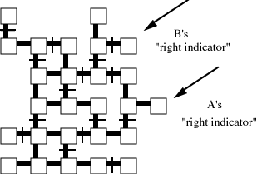

Figure 1. Schematic illustration of the maze being described in the transcript in Table 1. The arrows indicate the positions that A and B describe as right indicators.
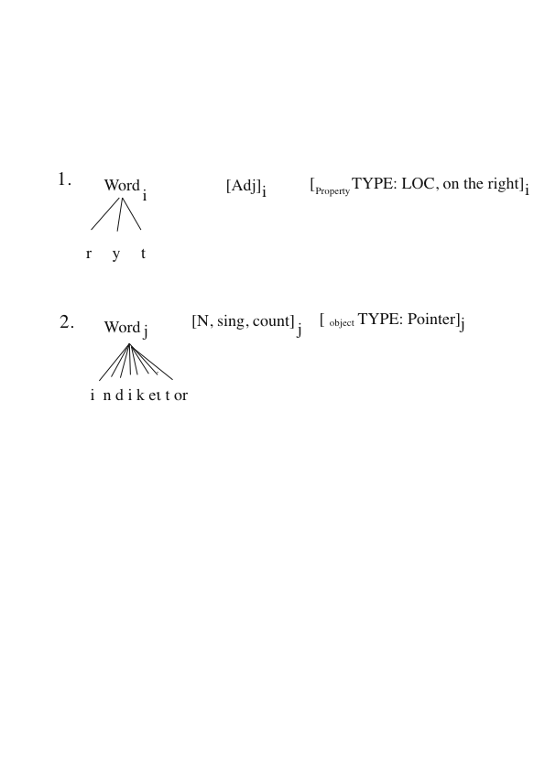
Figure 2. Schematic illustration of the lexical items right and indicator as accessed before establishing a routine for right indicator.
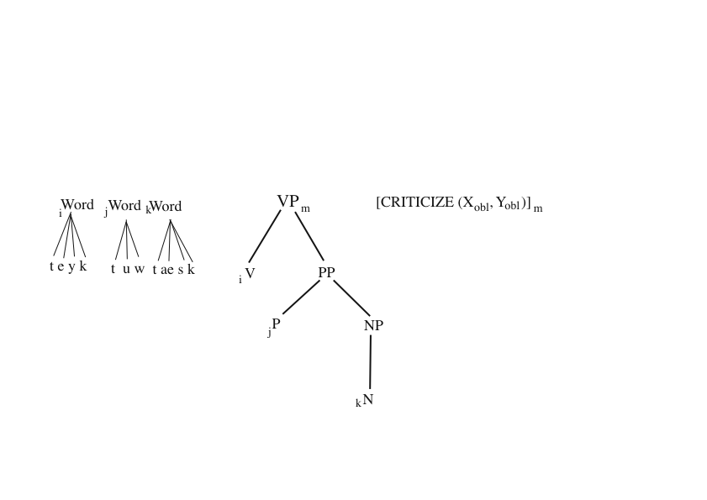

Figure 3. Schematic illustration of how take to task is represented as a lexical item in Jackendoff’s (2002) framework. By convention, subscripts on the left of a category (here, i, j, k) map the phonology to the syntax, whereas subscripts on the right (here, m) map the syntax onto the semantics.
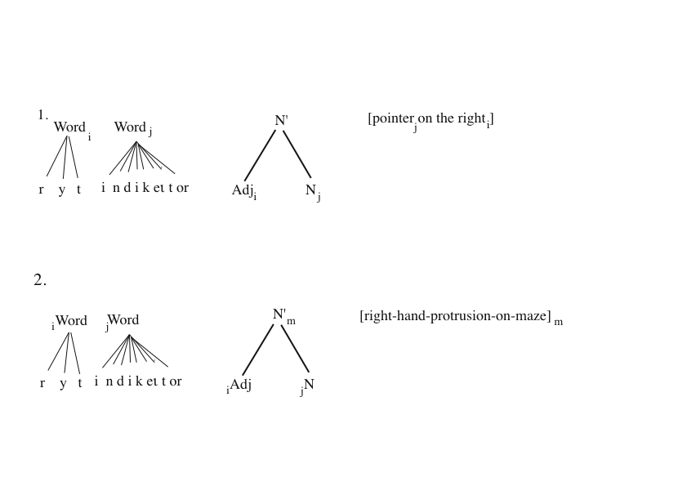Figure 4. Schematic illustration of (1) the standard interpretation for right indicator and (2) the lexicalisation of the dialogue routine for right indicator.
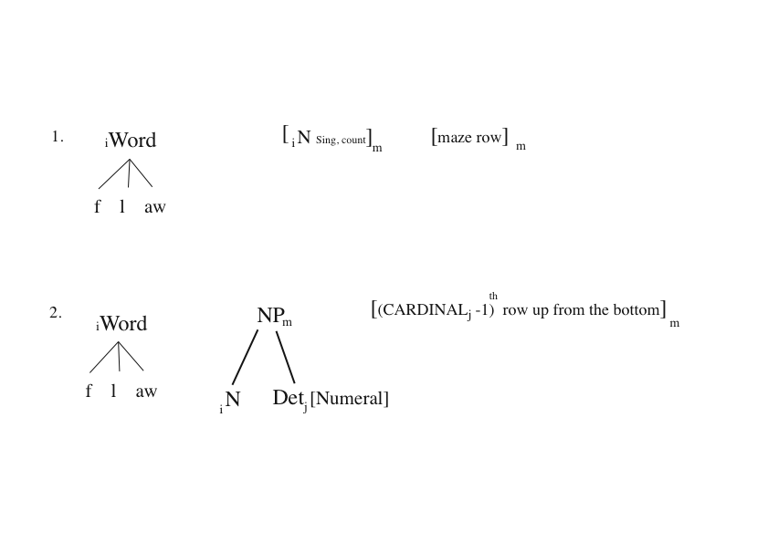
Figure 5. Schematic illustration of the lexicalisation of floor (1) when routinized to mean “row on the maze” and (2) when routinized to mean “row as ordered from the bottom of the maze”.
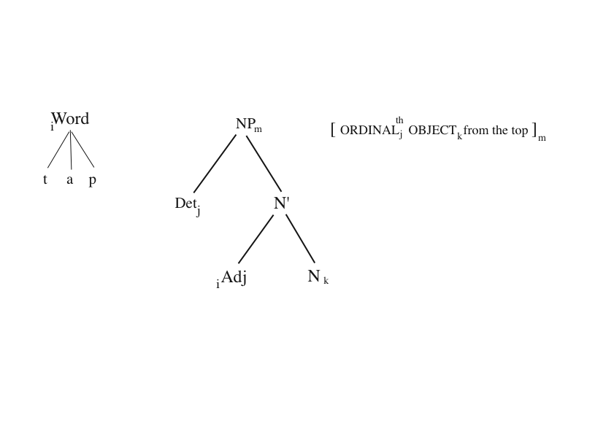
Figure 6. Schematic illustration of the lexicalisation of top when routinized to mean “as ordered from the top”.

