Understanding Interactive Graphical Communication

Nicolas Fay (nfay@atr.co.jp)

ATR Media Information Science Labs, 2-2-2 Hikaridai, Keihanna Science City,

Kyoto 619-0228, Japan

Simon Garrod (simon@psy.gla.ac.uk)

Department of Psychology, University of Glasgow,

Glasgow, G12 8QB, Scotland

John Lee (j.lee@ed.ac.uk)

Jon Oberlander (j.oberlander@ed.ac.uk)

HCRC, University of Edinburgh, 2 Buccleuch Place,

Edinburgh, EH8 9LW, Scotland

Abstract
We demonstrate several parallels between interactive verbal communication and graphical communication. Experiment 1 shows that through interaction partners’ graphical representations converge, and are refined, although degree of refinement is dictated by level of interaction. Experiment 2 shows that through interaction graphical representations lose their iconicity, taking on a more symbolic form. Again, this is dictated by the closeness of the interaction. Results are discussed both in terms of the evolution of writing systems and applications that support interactive graphical communication.

Background
We are exposed to pictures, diagrams and symbols of many different kinds every day, and more often than not, many times a day. A graphic may signal where the toilet is, or it may indicate that you cannot park your car in a particular area. Indeed, in reading this paper you are party to graphical communication, the symbolic script conveying the research of the above authors.
It is widely believed that most writing systems were derived from pictures drawn to represent meaning directly (Gelb, 1963). Japanese Kanji provides a clear example of this. While Kanji take their origin in pictographs, Kanji forms have changed over time, with few Kanji retaining their original pictographic form. The development of two Kanji characters is provided in Figure 1. To enable faster writing, Kanji have been schematized, their complexity reduced through the removal of peripheral information, such that their meaning has become more indirect, or symbolic. For a comprehensive discussion of the origins of graphic productions see Tversky (1995).
Like the Kanji examples, graphical communication is typically thought to be a form of one-way communication (graphic to person). However, two-way, interactive graphical communication is a frequent occurrence (e.g. collaborative map sketching or architect-architect design interaction). A questionnaire study conducted by van Sommers (1984) illustrates that fifty percent of non-work related drawing activity involves drawings that take place with, or for, an audience.

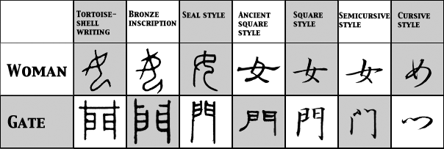
Figure 1. The change over time in two Kanji forms.

While research has addressed applied aspects of interactive graphical communication, such as when electronic whiteboards are useful (Bly, 1988; Whittaker, Brennan & Clark, 1991; Whittaker, Geelhoed & Robinson, 1993), few have investigated the principles governing interactive graphical communication (Healey, Swoboda, Umata & Katagiri, 2001; Healey, Swoboda, Umata & Katagiri, 2002). By comparing the process of interactive graphical communication with that of verbal communication, we address this fundamental question.
Arguably the most dominant model of interpersonal communication is the Collaborative Model (Clark & Wilkes-Gibbs, 1986). According to the Collaborative Model, the successful transfer of meaning between speaker and addressee is established through their interaction, undertaken to ensure that what is said is mutually agreed, or grounded (Clark & Schaefer, 1987). Furthermore, conversationalists ground information using the least collaborative effort (Clark & Wilkes-Gibbs, 1986).
Support for the Collaborative Model has been gained using a verbal referential communication task (Krauss & Weinheimer, 1964; Clark & Wilkes-Gibbs, 1986). In the Clark and Wilkes-Gibbs study a speaker and addressee interact, verbally, to identify a set of abstract geometric shapes. Over repeated games, referring expressions become shorter and more concise, such that a figure initially described as ‘a person who’s ice skating, except they’re sticking two arms out in front’ is described as ‘the ice skater’ by the sixth game. In addition to this reduction in collaborative effort, description type moves from an iconic form (description of what the figure looks like) to a more symbolic, or abstract form. Furthermore, understanding of the referring expression is determined by degree of participation in the dialogue, such that overhearers, side-participants and bystanders understand less of what is said when compared with active participants (Schober & Clark, 1989; Wilkes-Gibbs & Clark, 1992).
Other, related research addresses the convergence in referring expressions brought about by interaction. Having partners play a computerised maze game, Garrod and Anderson (1987) observed that the referring expressions used by one partner predicted those used by the other partner. This observation led to the notion of ‘input-output co-ordination’, that conversational partners linguistically entrain one another through their interaction, which in turn simplifies the process of production and comprehension.
To illuminate the principles of interactive graphical communication we created a graphical referential communication task. Like the well-known game ‘Pictionary’, participants interact, graphically, in order to identify concepts from a list. Having concepts recur over games made it possible to study the effects on interaction upon representational form.

Experiment 1
Experiment 1 investigates the influence of graphical interaction upon graphical refinement and convergence.

Task and Procedure
The task is the graphical equivalent of a verbal referential communication task. Like the game ‘Pictionary’, participants are required to depict various concepts, in such a way that a partner can identify them. Again, like ‘Pictionary’, participants are not allowed to speak or use letters in their drawings. Unlike ‘Pictionary’, concepts are drawn from a list of 16 items, which are known to both participants. Concepts include easily confused groups such as drama, soap opera, theatre, Clint Eastwood and Robert DeNiro (see Figure 2 for a complete listing).
The director, or drawer, depicts the first 12 items from an ordered list (12 targets plus 4 distracters) such that the matcher, or chooser, can identify each drawing from their unordered list. Both participants are permitted to draw. Subjects play six games using the same set of items (presented in a different random order on each game), alternating roles (director or matcher) from game to game. Alternating the drawing and matching roles allows an investigation of interaction upon both graphical refinement and convergence.
Drawing took place on a standard whiteboard. Participants’ drawings were recorded on digital camera.

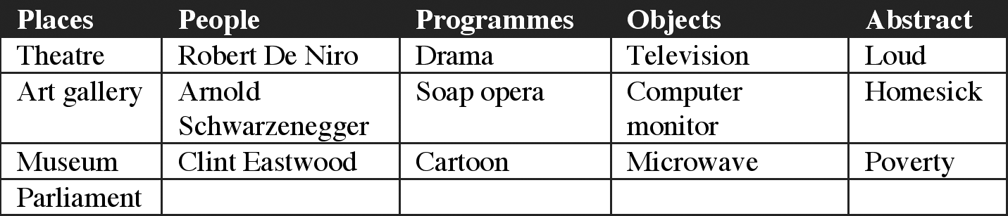
Figure 2. Items used in the graphical communication task.

Design
The influence of interaction upon representational form was studied at three levels, high, low and zero interaction. In the high, or full interaction condition, graphical interaction took place in real-time, partners standing side-by-side at the whiteboard. This condition is synonymous with face-to-face verbal communication. In the low interaction condition, a visual barrier separated partners during drawing. This condition is comparable to Email communication, in that participants’ exchange completed drawing turns. Finally, in the zero interaction condition participants carried out the task alone, communicating to a future partner who they were told would be presented with their drawings at a later date. This condition was necessary to ensure that effects observed in the interaction conditions were caused by interaction, not repetition.

Subjects
The participants were 80 undergraduates, each of whom were randomly assigned to the experimental conditions, high, low and zero interaction. 12 pairs participated in the high interaction condition, 16 in the low interaction condition and 12 individuals in the zero interaction condition. Each pair had not met prior to the experiment.

Results
Identification Accuracy. As can be seen from Figure 3, identification rates (proportion of items correctly identified by matchers) in the high and low interaction conditions were comparable. In both cases, identification rates improved across games.
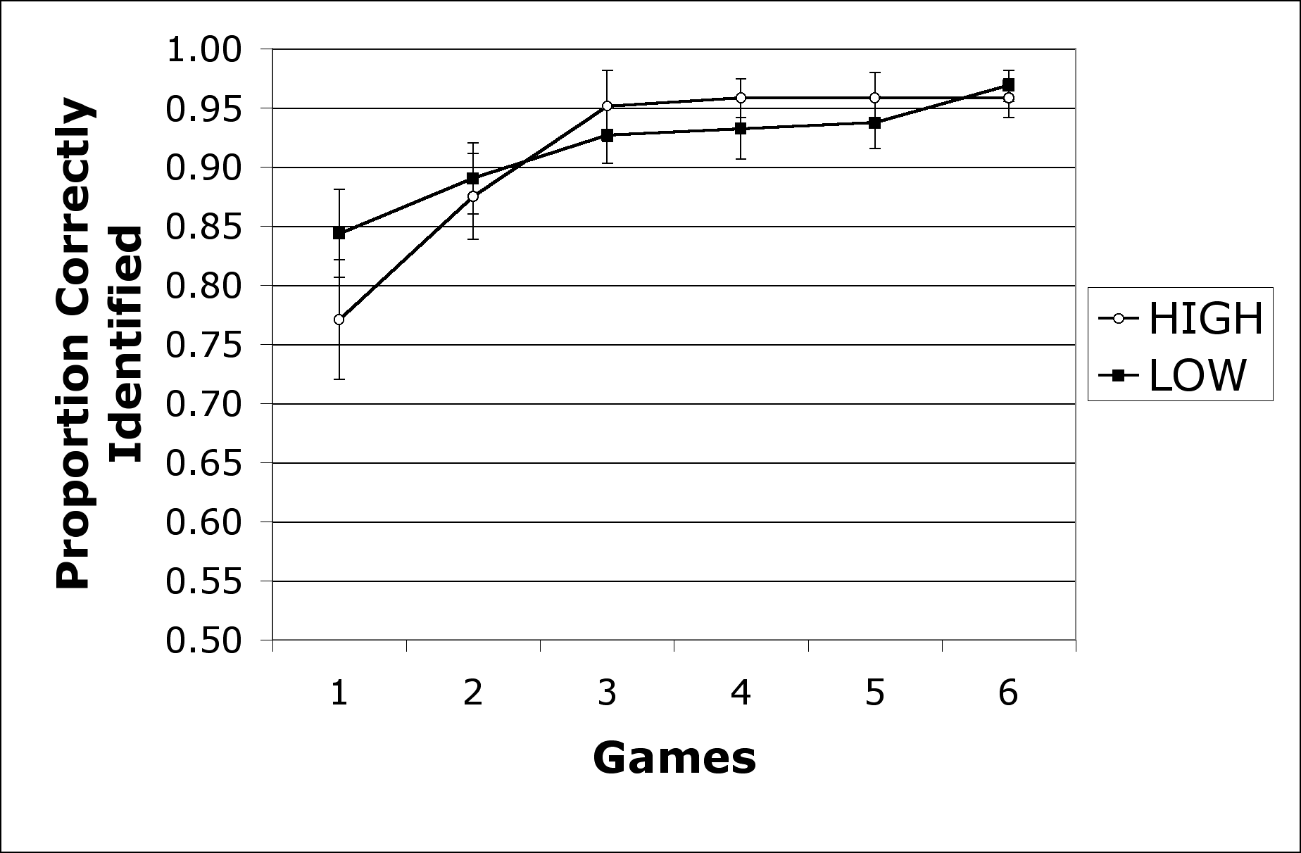
Figure 3. Mean proportion of items correctly identified by matchers in the high and low interaction conditions across six games of the task.

Proportion scores were entered into a 2 x 6 Analysis of Variance (ANOVA). Analyses were carried out by subject (F₁) and by item (F₂). By subject tests used a mixed design, treating Level (high and low) as a between subject factor and Game (1 to 6) as within, while by item tests treated both factors as within. Analyses returned a main effect of Game F₁(5, 26) = 11.59 and F₂(5, 75) = 13.46, but no effect of Level, or interaction between Game and Level, Fs < 1.87 (for all results reported p < .01 unless otherwise stated). Thus, participants’ ability to identify their partner’s referent was not influenced by interaction level.

Graphical Refinement. To illustrate the typical changes in representational form across games we provide an example from each of the three conditions, high, low and zero interaction, given in Figures 4, 5 and 6 respectively.

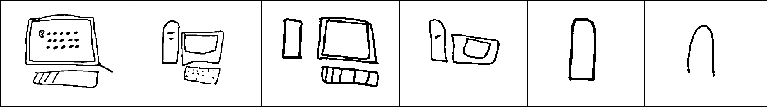
Figure 4. Computer Monitor over 6 games in the high interaction condition.

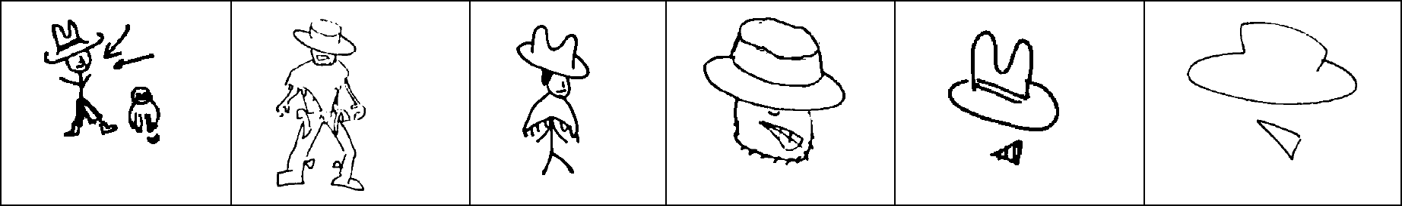
Figure 5. Clint Eastwood over 6 games in the low interaction condition.

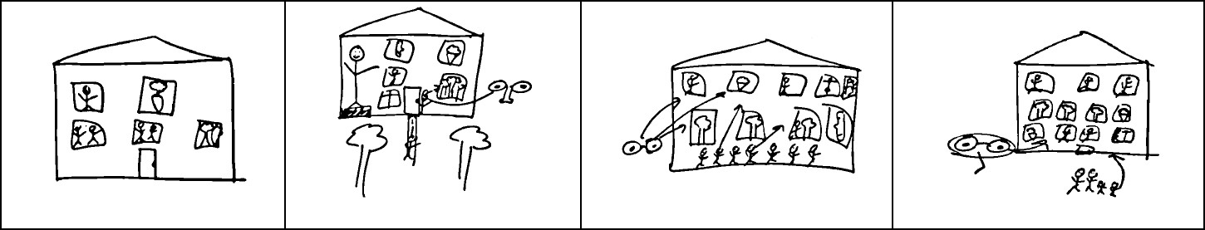
Figure 6. Art gallery over 4 games in the zero interaction condition.

Observe the reduction in graphical complexity of the drawings produced in the high and low interaction conditions (Figures 4 and 5). In both, the initial drawings take an iconic form, resembling the concepts they depict. However, through interaction participants minimize their collaborative effort, stripping unnecessary information from the initial representation, leaving only the salient aspects of the image. Note also, that through interaction participants’ representations converge; contrast the first two drawing by Drawer 1 and Drawer 2 of computer monitor and Clint Eastwood with the last two drawings made by the same participants. A very different pattern emerges in the zero interaction condition (Figure 6). Here participants’ drawings become more complex over games.
To quantify drawing complexity we adopted the Perimetric Complexity formula developed by Pelli, Burns, Farrell and Moore (2003), used to measure the visual complexity of letters, Complexity = Perimeter²/Ink. Using a subset of the drawings, we compared the human judgment of complexity (rank order) with the order produced by Pelli et. al.’s complexity measure (continuous measure transformed to rank order). There was a reliable correlation between the two, r = .66.
Figure 7 illustrates the changing complexity of drawings across games in the high, low and zero interaction conditions. The mean complexity scores were calculated after the removal of scores 2.5 standard deviations (SD) from the condition mean. These extremes were replaced with values corresponding to the mean plus or minus 2.5 SDs. Such cases accounted for only 1.92% of the data.

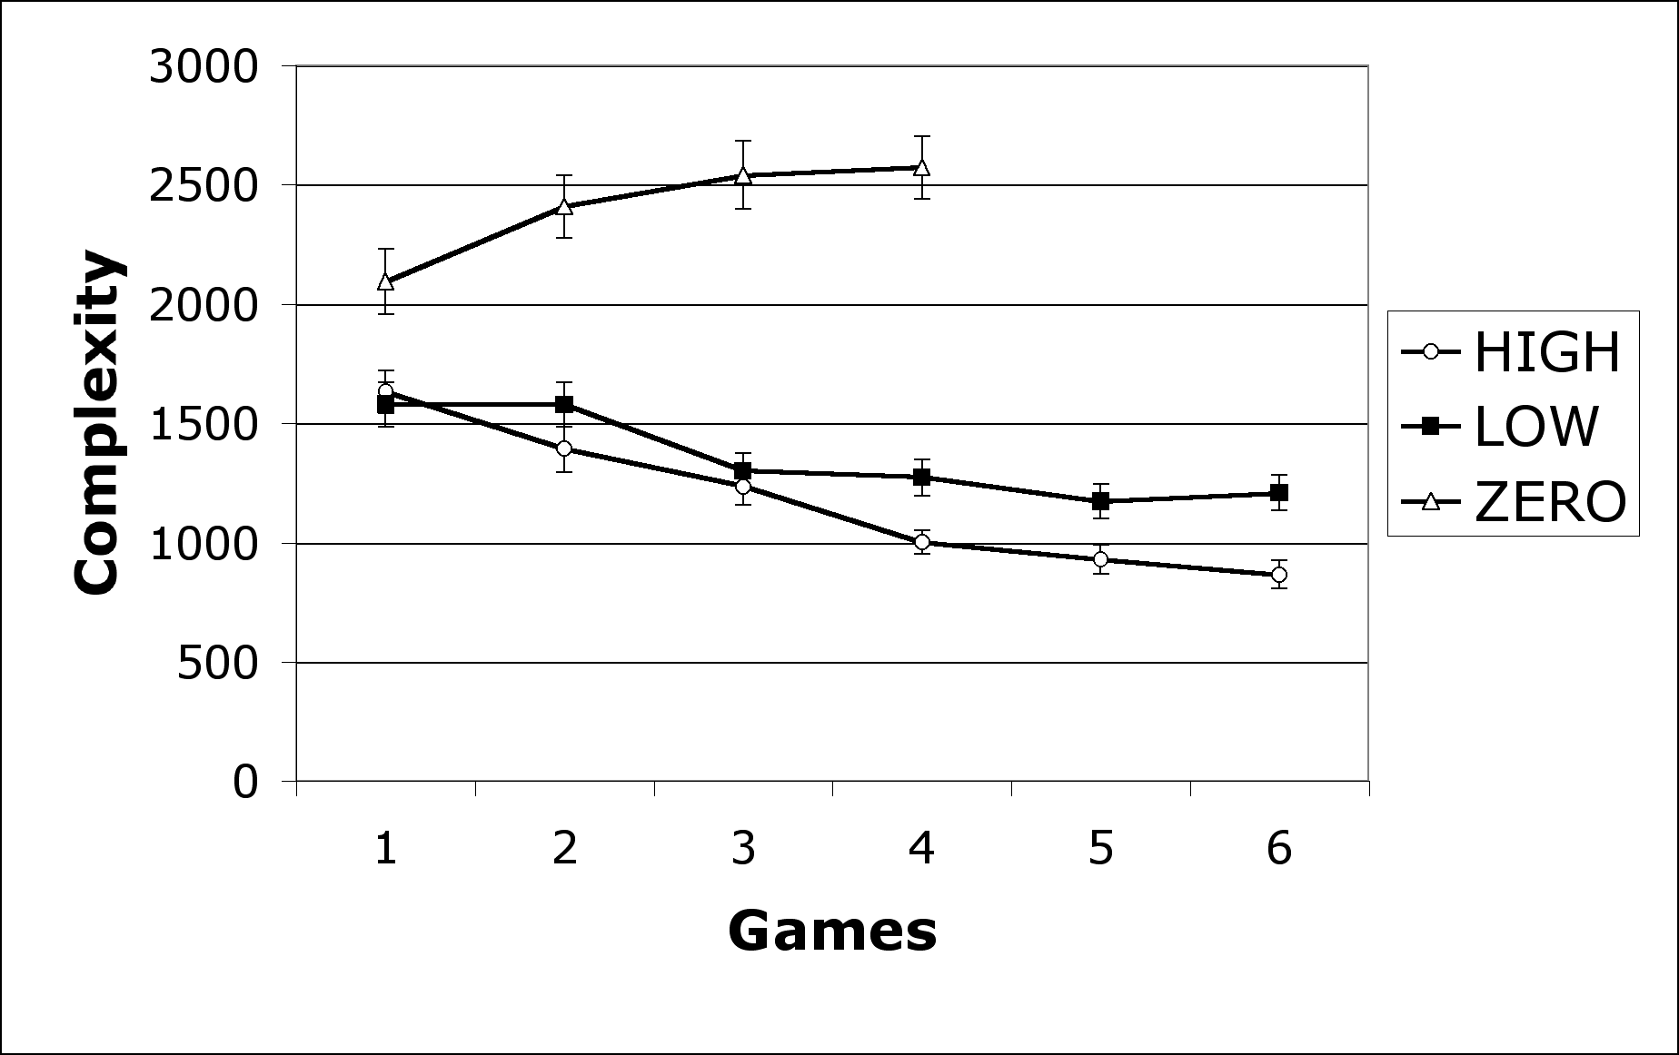
Figure 7. Mean Complexity (Perimeter²/Ink) of drawings across games in the high, low and zero interaction conditions.

In contrast to the zero interaction condition, where graphical complexity increases across games, in the high and low interaction conditions graphical complexity decreases. Note also that the complexity of drawings decreases more rapidly, and more smoothly in the high interaction condition. These observations are corroborated by ANOVA.
To accommodate the fewer games played in the zero interaction condition, the first ANOVA concerns only the first 4 games of the experiment. Complexity scores were thus entered into 3 x 4 ANOVA. By subject tests used a mixed design, treating Level (high, low and zero) as a between subject factor and Game (1 to 4) as within, while by item tests treated both factors as within. ANOVA returned a main effect of Level and Game, both of which were qualified by the interaction between Level and Game F₁(6, 37) = 8.11 and F₂(6, 90) = 32.65. Tests of simple effects corroborate the observations made above, namely that images produced in the zero interaction condition increase in complexity over games F₁(3, 111) = 5.60 and F₂(3, 45) = 17.96, whereas those in the high and low interaction conditions decrease in complexity over games, F₁(3, 111) = 8.06 and F₂(3, 45) = 26.57, F₁(3, 111) = 4.61 and F₂(3, 45) = 10.67 respectively.
Next, a 2 x 6 ANOVA compared the complexity of drawings produced in the six games played in the high and low interaction conditions. Although not reliable by subject, p > .10, by item tests show an interaction between Level and Game F₂(5, 75) = 5.78. As is evident from Figure 7, this was due to the continual reduction in drawing complexity by participants in the high interaction condition (between level effects of complexity are reliable at p < .01 from game 4 onwards).
Thus, as is the case in verbal communication, degree of interaction is important in graphical communication. Without interaction graphical representations become more complex across games. This effect reproduces those found in verbal referential communication tasks; without feedback speakers’ referring expressions become more elaborate (number of words) over games (Fussell, 1990; Hupet & Chantraine, 1992). Furthermore, more closely coupled graphical interaction allowed partners to maximally reduce their collaborative effort.

Graphical Convergence. Graphical convergence was studied using the images produced in the high and low interaction conditions. For each pair, the images for each item (e.g. drama, as drawn by each subject, i.e. Director 1 and Director 2) were placed in three categories: early (game 1 and 2 images), middle (game 3 and 4 images) and late (game 5 and 6 images). The images for each category were placed side by side on a sheet of A4 paper. To determine the influence of interaction upon graphical convergence, two independent coders ranked each item set (presented in a random order) in order of similarity. The pair of images thought to be most similar were given a rank of 1, those deemed to be least similar were given a rank of 3. Inter-coder agreement, on the item pair deemed most similar, was well above chance (50.1% agreement as opposed to 33.3% chance agreement).
As can be seen from Figure 8, graphical convergence increased across games. In both the high and low interaction conditions, a higher proportion of middle images were given a rank of 1 (most similar) when compared with early images. Also, more late images were ranked as most similar when compared with middle images.
The proportion scores were entered into two 2 x 2 ANOVAs. By subject tests treated Game (Early vs. Middle OR Middle vs. Late) as a between subject factor and Level as within (High vs. Low), while by item analyses treated both as within subject factors. The results were as predicted; middle game images were ranked most similar more often than early game images F₁(1, 26) = 11.05 and F₂(1, 15) = 13.27, and late game images were ranked most similar more often than middle game images F₁(1, 26) = 11.59 and F₂(1, 15) = 18.43. No other effects were reliable.
Thus, as is the case in verbal communication, where conversational partners entrain one another’s verbal expressions, partners’ graphical expressions converge through interaction. While coders reported that graphical convergence was clearer in the high interaction condition, corroborated by inter-coder agreement scores (52.8% agreement on images ranked most similar in the high condition as opposed to 47.4% agreement in the low interaction condition), our categorical measure does not permit an investigation of degree of graphical convergence.

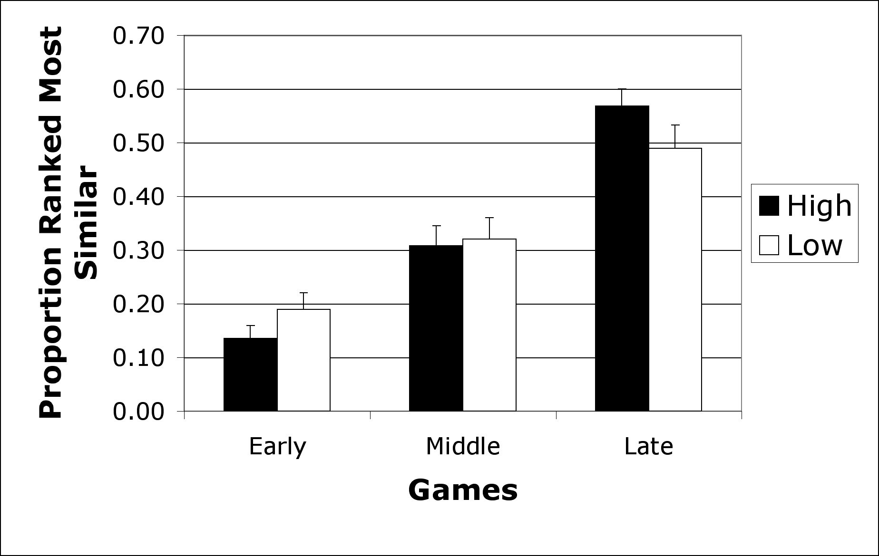
Figure 8. Mean proportion of high and low interaction condition images ranked most similar from the early (games 1 and 2), middle (games 3 and 4), and late (games 5 and 6) interaction games.

Experiment 2
To better understand the influence of interaction upon representational form, an ‘overseer’ experiment was run. Overseers’ ability to identify the drawings made by directors in the high, low and zero interaction conditions was compared. If, as predicted, interaction causes representations to move from an iconic to a more symbolic form, then overseers should more accurately identify director’s first drawings (prior to interaction) when compared with their last drawings.

Task and Procedure
Image sampling was conducted such that each ‘overseer’ was exposed to a comparable number of drawings made in the high, low and zero interaction conditions, and a representative sample of the different drawing types produced in each condition (e.g. art gallery, museum etc.). To negate the effect of interaction, only the images produced by the first director from each interacting pair were used (i.e. the director on game 1). Overseers’ identification success on this first drawing was compared with that of the third and final drawing made by the same director (i.e. game 5). The first and third drawings made by each director in the zero interaction condition were likewise sampled.
Each overseer was provided with a workbook containing 160 images (each image was seen by two overseers), presented in a random order. To the left of each image was a table that contained a list of the 16 possible identities of the image. Participants placed a tick in the box next to their choice. 16 participants acted as overseers in this study.

Results
Figure 9 displays the mean proportion of early and late drawings produced by directors in the high, low and zero interaction conditions that were correctly identified by overseers. It can be seen that the early and late drawings made in the low and zero interaction conditions were identified equally well by overseers. In contrast, overseers identified more of the early drawings than late drawings produced in the high interaction condition. These observations were corroborated by ANOVA.
Proportion scores were entered into 3 x 2 ANOVA, treating Level (High, Low and Zero) and Game (Early and Late) as within subject factors. Analyses revealed a main effect of Level which was qualified by the interaction between Level and Game F₁(2, 30) = 4.25, p < .05 and F₂(2, 30) = 3.84, p < .05. This interaction was caused by the simple effect of Game in the high interaction condition F₁(1, 15) = 5.37, p < .05 and F₂(1, 15) = 5.42, p < .05, with no such effect in the low and zero interaction conditions Fs < 1.
Thus, only in the high interaction condition are overseers less able to identify the directors’ later drawings. We can therefore conclude that these drawings contain less semantic information, or are less iconic, when compared with their earlier counterparts. This was not the case in the low and zero interaction conditions where early and late drawings were equally well identified by overseers.

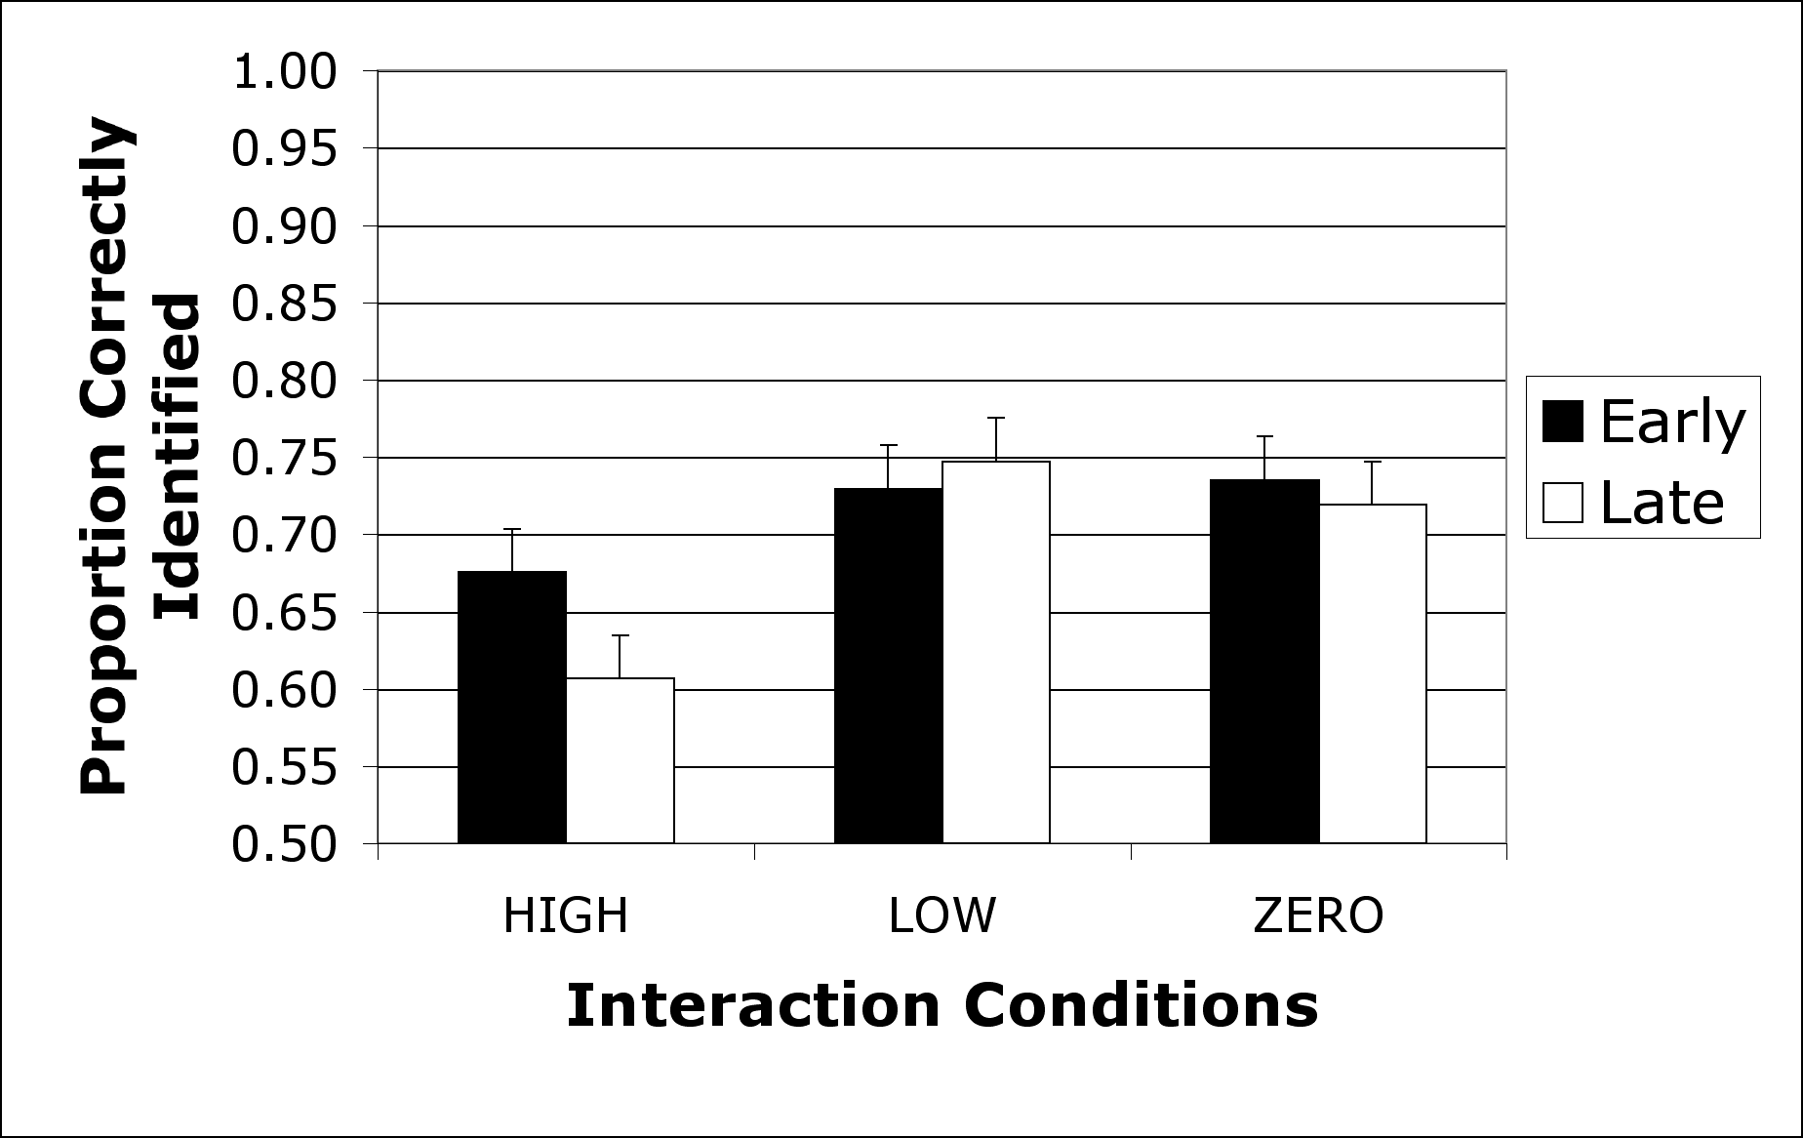
Figure 9. Mean proportion of Early (game 1) and Late (game 5 in the interaction conditions and game 3 in the zero interaction condition) drawings made by directors in the high, low and zero interaction conditions that were correctly identified by overseers.

Discussion
The studies reported here present evidence suggesting several parallels between verbal and graphical communication. Like verbal communication, graphical ‘conversationalists’ first ground (Clark & Wilkes-Gibbs, 1986) what they mean. Over repeated reference partners’ graphical representations converge and are refined. Again, like verbal communication this graphical convergence aids both the production and comprehension of future representations (Garrod & Anderson, 1987). The process of graphical refinement is dictated by degree of interaction, such that more closely coupled interaction facilitates greater refinement. Thus, closer graphical interaction enables partners to more substantially reduce their collaborative effort (Clark & Schaefer, 1987).
Furthermore, degree of interaction influences the semantics of the representation, such that overseers find high interaction partners’ later drawings difficult to identify. If iconicity can be measured on a scale ranging from icon to symbol, we can conclude that closely coupled graphical interaction causes representations to move toward the symbol end of the scale. Similar observations are made by Healey, Swoboda, Umata and Katagiri (2001), who found that more interactive graphical communication leads to a higher incidence of abstract, as opposed to figurative, representations. Comparable findings have been made in verbal referential communication tasks, where verbal descriptions are found to contain more definite reference (e.g. ‘the ice skater’) in high interaction conditions (Traxler & Gernsbacher, 1992).
Comparison of identification rates between matchers (Game 1 = 81%, Game 5 = 95%) and overseers (Game 1 = 70%, Game 5 = 68%) suggest an ‘overseer effect’ comparable to that found in verbal referential communication tasks (Schober & Clark, 1989). However, before such a claim can be substantiated, a full overseer experiment is required, where overseers are party to the build up of common ground between director and matcher (i.e. real time observation of drawing activity in each game).
The observed schematization of drawings across games, particularly those in the high interaction condition, bear a striking similarity to the evolution of writing systems, such as the Kanji system documented in Figure 1. While the development of writing systems has generally been attributed to changes in writing medium (e.g. shells to bronze to paper. See Tversky, 1995), the results reported here suggest this explanation may underestimate the importance of interaction.
Finally, from an applied point of view, the research reported emphasizes the importance of coupling, or concurrency, to devices that support multiparty interactive graphical communication. Only through closely coupled interactions can partners fully realize the potential of interactive graphical communication.

Acknowledgments
This research was supported in part by the Telecommunications Advancement Organization of Japan, and the ESRC and EPSRC (grant L323253003). We are grateful to Yasuhiro Katagiri, Nik Swoboda and two anonymous reviewers for their helpful comments on an earlier draft of this paper.

References
Bly, S. A. (1988) A Use of Drawing Surfaces in Different Collaborative Settings. Proceedings of the Conference on Computer Supported Cooperative Work, Portland, OR, Sept 1988, Pages 250-256.
Clark, H. H., & Schaefer, E. F. (1987). Collaborating on contributions to conversation. Language and Cognitive Processes, 2, 19-41.
Clark, H. H., & Wilkes-Gibbs, D. (1986). Referring as a collaborative process. Cognition, 22, 1-39.
Fussell, S. R. (1990). The effects of intended audience on message production and comprehension: Reference in a common ground framework. Unpublished doctoral thesis, Columbia University, New York.
Garrod, S., & Anderson, A. (1987). Saying what you mean in dialogue: a study in conceptual and semantic co-ordination. Cognition, 27,181-218.
Gelb, I. (1963). A study of writing. Second Edition. Chicago: University of Chicago Press.
Healey, P. G. T., Swoboda, N., Umata, I., & Katagiri, Y. (2001). Representational form and communicative use. In Moore J.D. and Stenning, K. (Ed.s) Proceedings of the 23rd Annual Conference of the Cognitive Science Society. 1-4 August, Edinburgh, Scotland. pp. 411-416.
Healey, P. G. T., Swoboda, N., Umata, I., & Katagiri, Y. (2002). Graphical representation in graphical dialogue. International Journal of Human Computer Studies. Special Issue on Interactive Graphical Communication. 57(4), pp. 375-395.
Hupet, M., & Chantraine, Y. (1992). Changes in repeated references: Collaboration or repetition effects? Journal of Psycholinguistic Research, 21, 485-496.
Krauss, R. M. & Weinheimer, S. (1964). Changes in reference phrases as a function of frequency of usage in social interaction: A preliminary study. Psychonomic Science, 1, 113-114.
Pelli, D. G., Burns, C. W., Farrell, B., & Moore, D.C. (2003). Identifying letters. Vision Research, Accepted with minor revisions.
Schober, M. F., & Clark, H. H. (1989). Understanding by addressees and overhearers. Cognitive Psychology, 21, 211-232.
Sommers, P. van. (1984). Drawing and cognition: Descriptive and experimental studies of graphic production processes. Cambridge: Cambridge University Press.
Traxler, M. J., & Gernsbacher, M. A. (1992). Improving written communication through minimal feedback. Language and Cognitive Processes, 7, 1-22.
Tversky, B. (1995). Cognitive origins of graphic conventions. In F. T. Marchese (Editor). Understanding images. pp. 29-53. New York: Springer-Verlag.
Whittaker, S., Geelhoed, E., & Robinson, E. (1993). Shared workspaces: how do they work and when are they useful? International Journal of Man-Machine Studies, 39, pp 813-842.
Whittaker, S., Brennan, S., & Clark, H (1991). Co-ordinating activity: an analysis of computer supported cooperative work. In Proceedings of CHI'91 Human Factors in Computing Systems, New Orleans, USA, Eds., S. Robertson, J. Olson & G. Olson, NY: ACM Press, 360-367.
Wilkes-Gibbs, D., & Clark, H. H. (1992). Coordinating beliefs in conversation. Journal of Memory and Language, 31, 183-194.

With those in the zero interaction condition not having a partner, it was not possible to gauge identification success.
Due to the reported difficulty of the task, and time required to complete the task, participants played 4 games in the zero interaction condition.

